Sometimes, there is a scenario that jenkins job should only be triggerred on the basis of another job. For instance, regression suite in jenkins should only be triggerred if smoke suite is passed.

Refer the following configuration. It is working fine

Job 1: Regression suite: This job is executed only when the smoke suite is passed.

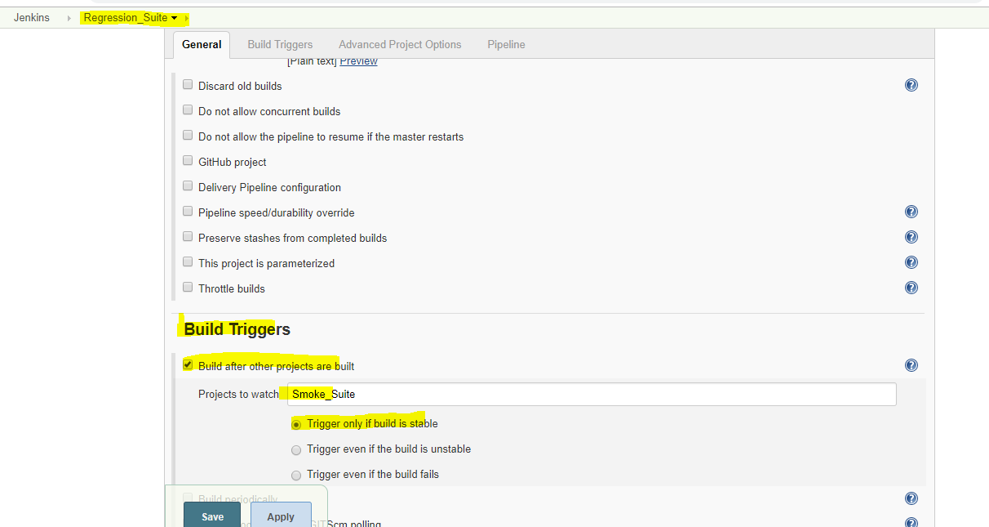

Job 2: Smoke Suite

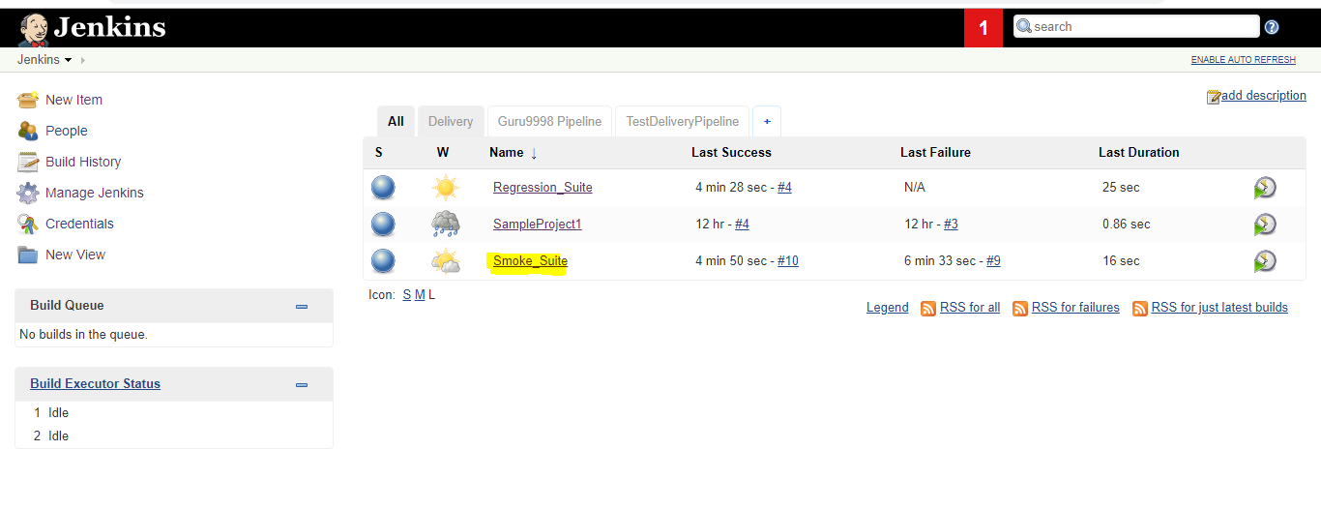

It has been tested , regression suite was got only executed when the smoke suite build was successful.